Letter of Intent

To whom it may concern,
I grew up in Poland, lived in Thailand and finished highschool in the Netherlands. I have always attended international schools with an English based education, hence am confident of my verbal and written communication skills. I possess high cultural awareness and sensitivity due to my routined travel and life abroad. I have always been a high level athlete, which has led to strong mental strength and stability. In my teenage years I overcame serious challenges due to persistence. During highschool I became involved in employment agencies, and consistently put in maximum effort completing various tasks. I graduated with an IB diploma where I scored 34 points (Honor Role). At a young age I learned discipline; I noticed that my satisfaction during work comes from my impact on the results. When I turned 18, I began learning and trading in the stock market. My rationed and straight forward thinking generated positive results.

I am always looking to improve any aspects of a firm to become more efficient. My entrepreneurial mindset originated through working for others. I set-up an unofficial gardening focused company in 2018 (age 17), Through this, I learned to effectively market my work through social media with use of skills learned in the past. Over time, a solid customer base helped me create and strengthen the brand image. Through hiring associates I built upon my management and motivational leadership skills. Currently my focus is on school, yet I maintain my brand through interaction with customers. My motivation is driven by responsibility as well as decision making power, rather than security and stability in income.

My goal in the future is to have impact and responsibility for my work.I have the ability to constantly push at 100% physically and mentally until the objective is achieved. Due to this, I fit a working environment where my consistent determination is utilized to a maximum. I am extremely hard working when motivated, and always entirely goal oriented, I am most excited to help develop businesses.

I am currently on a 6 month exchange semester in Madrid. I am looking for work experience in a marketing related field. I am a third year international business (BA) student, with specialization in Marketing. As a requirement for school I need a minimum of 20 weeks work experience/internship, with a minimum of 36 hours per week (full-time). After this, I have a semester in which I write a thesis based on a company. I am open to keep working with the company to further develop my skills and base my thesis on improving an aspect within the company. I have attached my IB grades list on the next page, as well as a list of courses I have followed in my Marketing major. I am currently in Madrid on exchange, and am looking for a 20 week internship where I can dedicate myself fully to your company. The plan is to start in the first week of September, but I am flexible and could come earlier. This will be my final period (apart from thesis) in my bachelor degree. Therefore, I can continue working full time should both parties be satisfied with the performance. Please let me know what you think.

Thank you for reading. Hope to hear from you soon!
stanbrinkman@live.com
+31 6 83 20 73 53

IB Results Summary:
(Results can have a maximum grade of 7. Maximum points without EE/TOK points is 42)
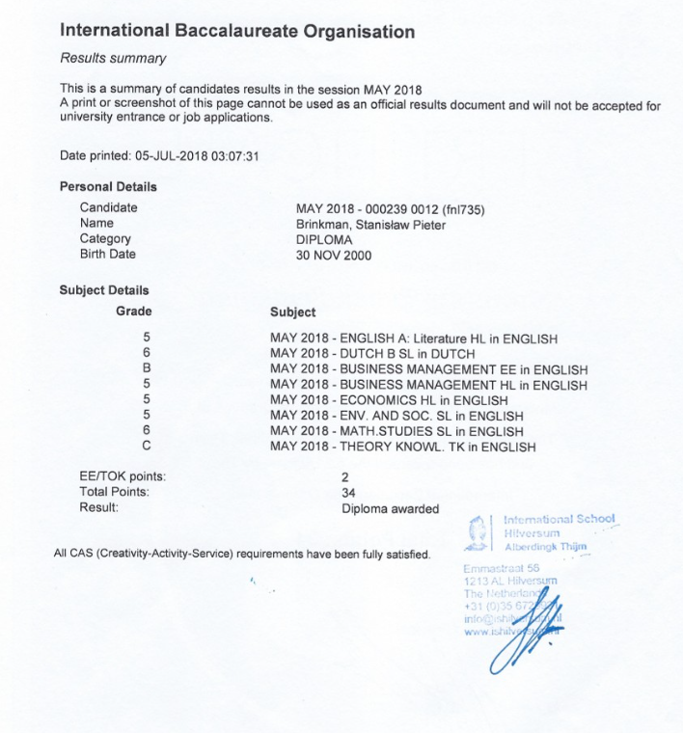
Marketing Major Course List:
(Results can have a maximum grade of 10)
